**Summary on Software Testing Style**

**1 - Unit Testing**

Unit testing is a software testing method where individual units or components of a software application are tested. Unit testing helps ensure software reliability, stability, and maintainability.

**Key aspects:**

1. Smallest testable unit: Typically a single function, method, or module.

2. Isolation: Tested independently of other components.

3. Automated: Usually performed using automated testing frameworks.

**Benefits:**

1. Early defect detection: Identifies issues early in development.

2. Improved code quality: Encourages modular, maintainable code.

3. Faster debugging: Quickly identifies problematic areas.

**Best practices:**

1. Write test cases: Create comprehensive test suites.

2. Test-driven development (TDD): Write tests before writing code.

3. Keep tests simple: Focus on specific functionality



**2 - Integration Testing**

Integration testing is a software testing method where individual units or components are combined and tested as a group to ensure they work together seamlessly

**Key aspects:**

1. Combining units: Integrating multiple components or modules.

2. Interactions: Testing how components interact with each other.

3. Interfaces: Verifying data exchange and communication between components.

**Benefits:**

1. Detects integration issues: Identifies problems that arise when components interact.

2. Ensures system stability: Verifies that integrated components work together as expected.

3. Reduces system failures: Helps prevent errors that occur when components are integrated.

**Types:**

1. Top-down: Testing from highest-level components to lowest-level components.

2. Bottom-up: Testing from lowest-level components to highest-level components.

3. Hybrid: Combination of top-down and bottom-up approaches.

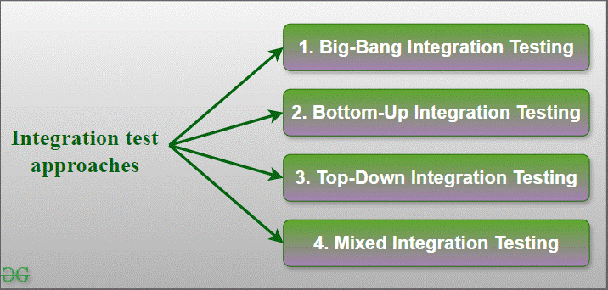

**3 - Load Testing**

Load testing is a software testing method that evaluates a system's performance under expected and peak loads. Load testing helps ensure software systems can handle expected and unexpected loads, providing a better user experience and reducing the risk of system failures.

**Key aspects:**

1. Simulated traffic: Mimics real-world usage with multiple users or requests.

2. Performance metrics: Measures response time, throughput, and resource utilization.

3. Scalability: Tests system's ability to handle increased load.

**Benefits:**

1. Identifies bottlenecks: Reveals performance issues under heavy loads.

2. Ensures scalability: Verifies system can handle increased traffic or usage.

3. Improves reliability: Helps ensure system stability and performance under various conditions.

**Goals:**

1. Determine breaking point: Find the maximum load system can handle.

2. Measure performance: Evaluate system's response time, throughput, and resource utilization.

3. Optimize system: Identify areas for improvement to enhance performance and scalability

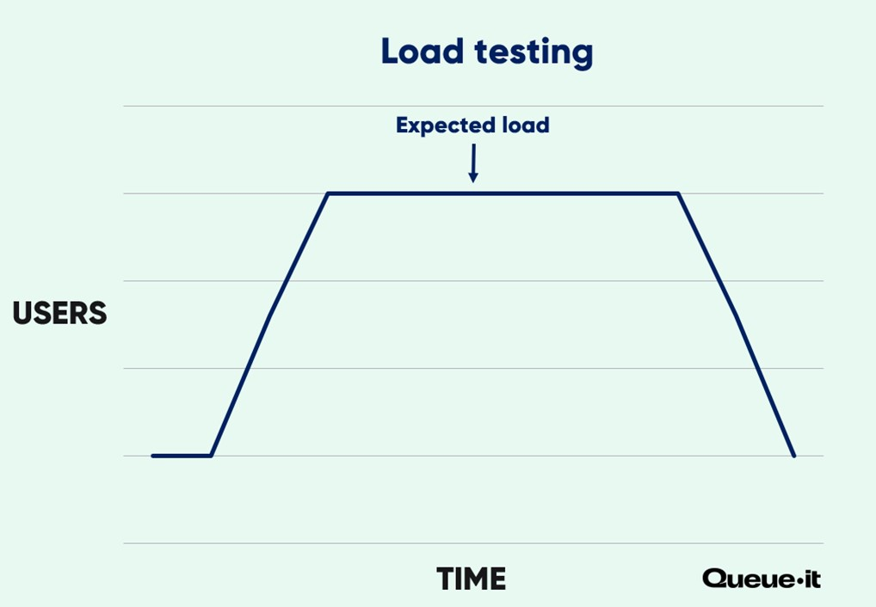

**4 - API Testing**

API testing is a software testing method that verifies the functionality, reliability, and security of Application Programming Interfaces (APIs).

**Key aspects:**

1. Request and response: Tests API endpoints, request methods, and response formats.

2. Data validation: Verifies API returns correct data, handles errors, and validates input.

3. Security: Tests API security, authentication, and authorization.

**Benefits:**

1. Ensures functionality: Verifies API works as expected.

2. Improves reliability: Identifies and fixes API issues.

3. Enhances security: Identifies vulnerabilities and ensures data protection.

**Types:**

1. Functional testing: Tests API functionality.

2. Performance testing: Tests API performance under load.

3. Security testing: Tests API security vulnerabilities.

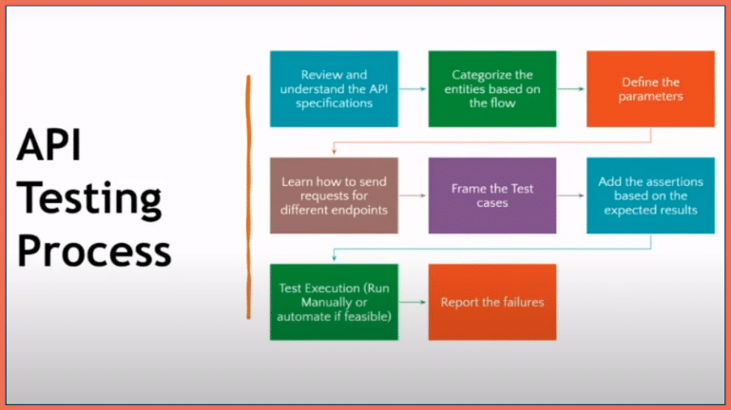

**5 - UI Testing**

UI testing is a software testing method that verifies the functionality and usability of a user interface (UI)

**Key aspects:**

1. Visual inspection: Tests UI layout, design, and visual elements.

2. Interaction: Verifies user interactions, such as clicks, inputs, and navigation.

3. Usability: Tests UI's ease of use, intuitiveness, and user experience.

**Benefits:**

1. Ensures usability: Verifies UI is user-friendly and intuitive.

2. Identifies issues: Catches UI-related defects and bugs.

3. Improves user experience: Enhances overall user satisfaction.

**Types:**

1. Manual testing: Human testers interact with the UI.

2. Automated testing: Tools automate UI testing.

